Summary and Reflections Report
1. Summary
The unit testing that I applied to each of the three features built for this application was to verify strict adherence to the requirements provided by the customer. The features requested by the customer had requirements that included length and type of input, whether an entry could be null, unique and immutable IDs, and making certain class objects updatable. When building the code, each of these requirements was carefully addressed in such a way that an object couldn’t be created unless it met all the listed requirements. When a variable of an object like a unique ID needed to be less than 10 characters and not null, an IllegalArgumentException is thrown for each and any of the requirements not met. This means that each requirement is individually tested when validating the input. 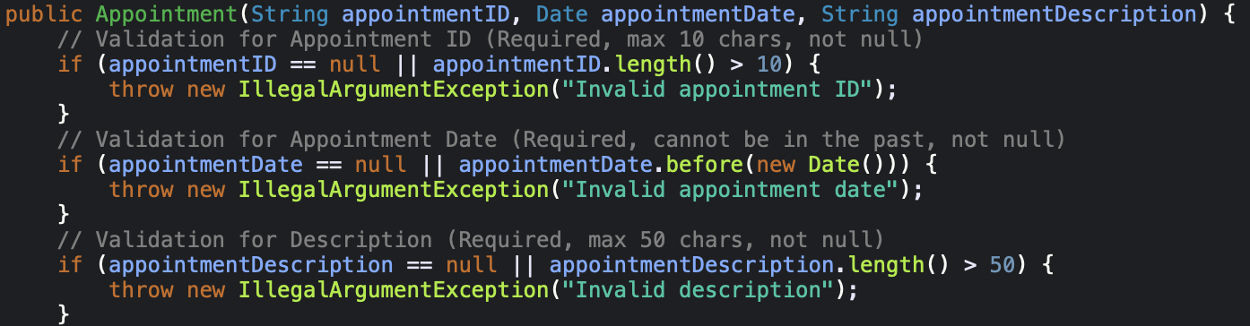
The JUnit tests where then also written to trigger for each individual instance of requirement to confirm that the exception triggers if the ID is not unique (repeat), 10 characters or less, or null. The concept of testing each requirement on an individual basis is key in securing and validating each piece of data associated with an object. The other side is to ensure that the code acts appropriately when all the input meets the requirements and the object is instantiated properly (happy case).
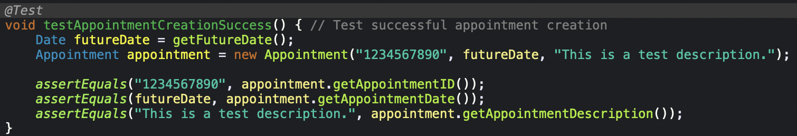
The quality of the code for each service as well as the test themselves can be confirmed with coverage metrics, JUnit test successes/failures, and manual code reviews to very and address any potential oversights. When the tests she me the coverage and successful unit tests, I can then review any remaining code that may not have executed during testing. This allows me to determine that either the code not executed would not affect the performance of the software, or I can write additional tests to increase testing coverage.
I made sure that my code was technically sound by adhering to industry best practices when building the application and corresponding tests. For example, instead of hardcoding a date for the Appointment objects that may eventually fall out of spec, I created a method that would always pull a date from the future regardless of when the tests were conducted. This would ensure that the date variable of the appointment object would execute as intended. I also used the @BeforeEach annotation of the JUnit framework to ensure that each test runs with a clean state of the AppointmentService object.
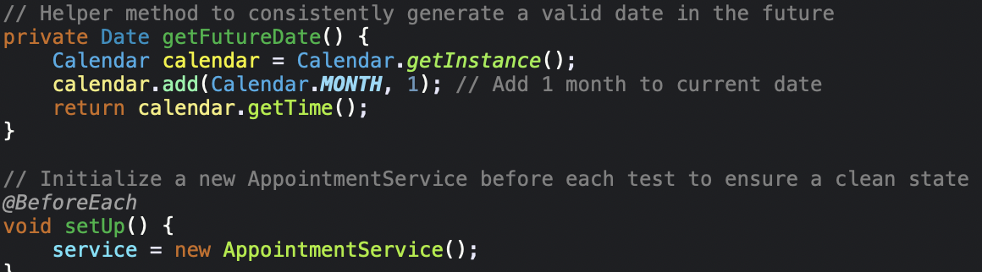
In an effort to keep the code as efficient as possible, I also made sure to use the lambda syntax when writing the JUnit tests. Instead of writing try-catch blocks and manual calls of a method to catch failed code, the lambda syntax gives precise execution of each test and can help pinpoint exact moments of code failure.
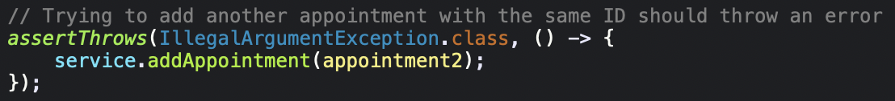
2. Reflection
The main types of testing implemented in the milestones that come to mind fall under the White Box Testing column. They include “Happy Path” testing, Exception testing, and Isolation testing. These were all done with Junit 5 framework tests. Happy path testing is testing input that meets all the requirements and produces an expected output. A specific example is in the Appointment.java file, adding an appoint successfully that met all the criteria like unique ID, future date, character limits, etc. Exception testing is testing that the validation efforts are implemented correctly and that the code responds and throws exceptions when met with input that doesn’t align with the requirements. Examples from the Appointment.java file include throwing exceptions and outputting error messages when an ID was null, or if the character limit of the description exceeded its limit. This was done using Junit assertions after intentionally giving bad input. Isolation testing was done by testing each of the above-mentioned tests by running a new instance of AppointmentService using the @BeforeEach annotation. This allowed each test to run in a clean state assuring me that any Junit tests that came back positive or negative were strictly for that piece of code and not “left over” from previous software states.
Two main types of testing that come to mind that I did not do for these milestones are Black Box testing and integration testing. Black Box testing would be done later in the software development lifecycle. This would be testing all the code together as an end-user, finding bugs with the user interface, and ensuring the final product meets client requirements. I have not reached that point of this software therefore it is not necessary to pursue this type of testing at this point in the project. Integration testing is another type of testing that I did not implement during these milestones. Since I am currently working with simple logic flow of these individual java files, I have not had the need to integrate this code with any APIs or databases. Currently all the logic happens in memory. As of this moment I only know how each of these package’s functions on an individual level.
Junit testing did most of the heavy lifting for the tests that I did run while writing the code for these three milestones. Junit testing is beneficial in real life projects because it helps to verify that your codes logic falls within the requirements set forth by the client. It checks that correct input acts as it is supposed to as well as catching any exceptions for input outside of those bounds. This is also useful down the line if changes are made to the code and logic that previously acted appropriately is no longer correct, you can pinpoint where the flow is interrupted based on which test is failing. This type of White Box testing is important for a developer to hand off a working product in the best possible order before more rigorous end-user testing happens like that of Black Box testing. Black Box testing is the final test drive of the software as a whole and is your last chance before sending off a “finished” product to the client. This is where we integrate each unit of the software and bring it all together. It’s like we built each piece of the car along the way, and Black Box testing it putting it all together, starting the engine and driving it. This is where we verify that the end user requirements are met, the software communicates properly with other databases and APIs, and we have a user-friendly product being handed off to the client.
It is important to employ caution while building the code that meets the requirements provided by the client. When creating the bases classes that worked directly with their respective service classes, it was extremely important to verify that all the validation and code execution was successful. One line of faulty code in the Appointment class for example would potentially cause catastrophic failures when the AppointmentService class tried to call on methods that didn’t function properly. Another issue could be if input wasn’t validated, it could cause damage to the has map.
I believe that removing personal bias completely from the development and testing process is close to impossible. As a developer we always want this code that we build to be perfect right out of the gate. That’s why it’s important to change the mindset to want to find issue with it. It would be easy to only write tests that show that it does what you want it to do, but shift happens when you decide that you want to break it and therefor are looking to make sure that the code does what the client needs it to do, not what you wrote it to do. In this project for this client, I made sure to write tests the specifically tested the code to see how it would react when intentionally given invalid input. This was done across multiple classes and all variables within each class.
Being disciplined in both development and testing of software has many positive effects that aren’t always acknowledged. It is important to stay professional and always deliver the highest quality of work. Putting in consistent effort can save you a lot of headaches down the line, especially in later stages of the development lifecycle. Early mistakes will compound and cost you exponentially more both in time and money. Down time for a customer could also cost you their business in the future. To avoid this technical debt, I plan to test everything that I can within a reasonable time frame and test often. Laying the foundation with quality code early is beneficial to everyone involved with the project.

